LAB 6 - Simple Networking in iOS Applications

Objectives
- Retrieve data via a network connection using Cocoa Touch APIs
- Use modal alerts to interrupt & inform the user

Tasks

Task 1 - Real Simple Synchronous Networking

The iOS SDK APIs include a number of networking helper methods on common classes. For example, NSArray and NSString both offer variants of the initializer -initWithContentsOfUrl:.

However, these methods are synchronous. The program waits for a response from the Web server before the method returns to your program. This means your user interface won’t be able to process interactions like touches. Your program will appear to stop responding for the duration of the API call.
- Create an application that uses the NSString class to download the contents of a user-provided URL. When the “Go” button is pressed, retrieve the URL and display the total number of characters in the retrieved content to the screen as a UIAlertView.
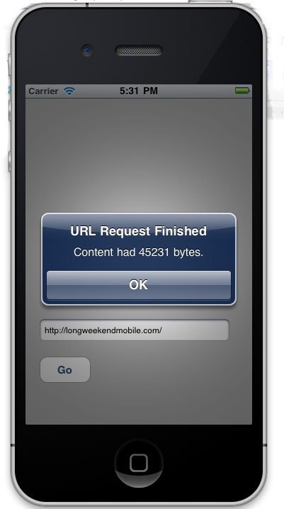
Task 2 - Y U NO INTERNET?

Internet connectivity “in the wild” can be sporadic. A 3G data network may not be available, the phone may be out of range, and/or the phone itself may be set to Airplane Mode. Finally, there’s always the chance that the remote host is unavailable.
- Unplug your computer’s Ethernet cable, turn off the Air Port, or if you are using a device, set your device to Airplane Mode (in short, make sure you have no Internet connection).
- With no Internet access, run the Task 1 application and observe the user experience. As a user, would you understand what is wrong? Write a short paragraph (up to 0.5 pages) explaining the user experience, and what the problem with this approach is.
- Update the application from Task 1 to include a simple alert that notifies the user of the failure. Take a screenshot of your alert after you have confirmed it works.

Task 3 - Abort, Retry, Ignore, Fail? _

Computer programs often give the user the chance to “Retry” when something fails. Often these retries are in vain (your hard drive is already dead), but in the case of networking, the user can usually remedy the connectivity problems and retry.
- Create an alert that informs a user of a networking problem. The alert should have 2 buttons: Retry and Cancel; when Retry is pressed, the operation should be attempted again. Implement this approach into your Task 1 code and take a screenshot of the alert view when displayed.

